Steps to shrink log files

Step 1 :- Go to the properties of that database and change its recovery model from full to simple .

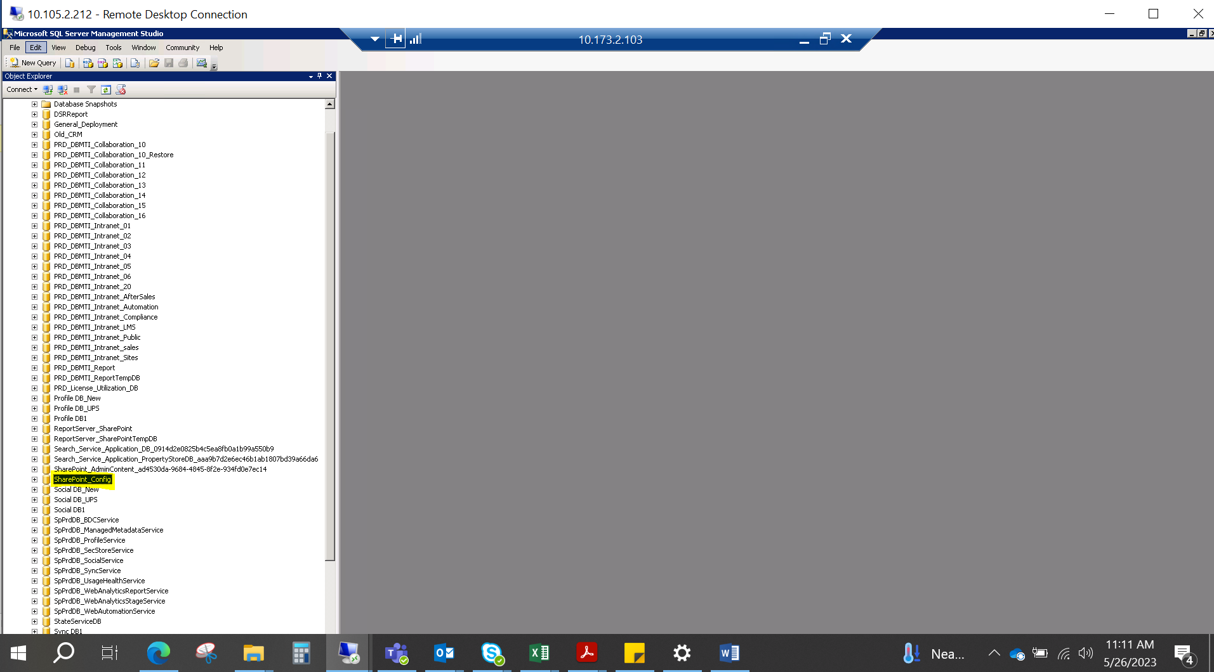

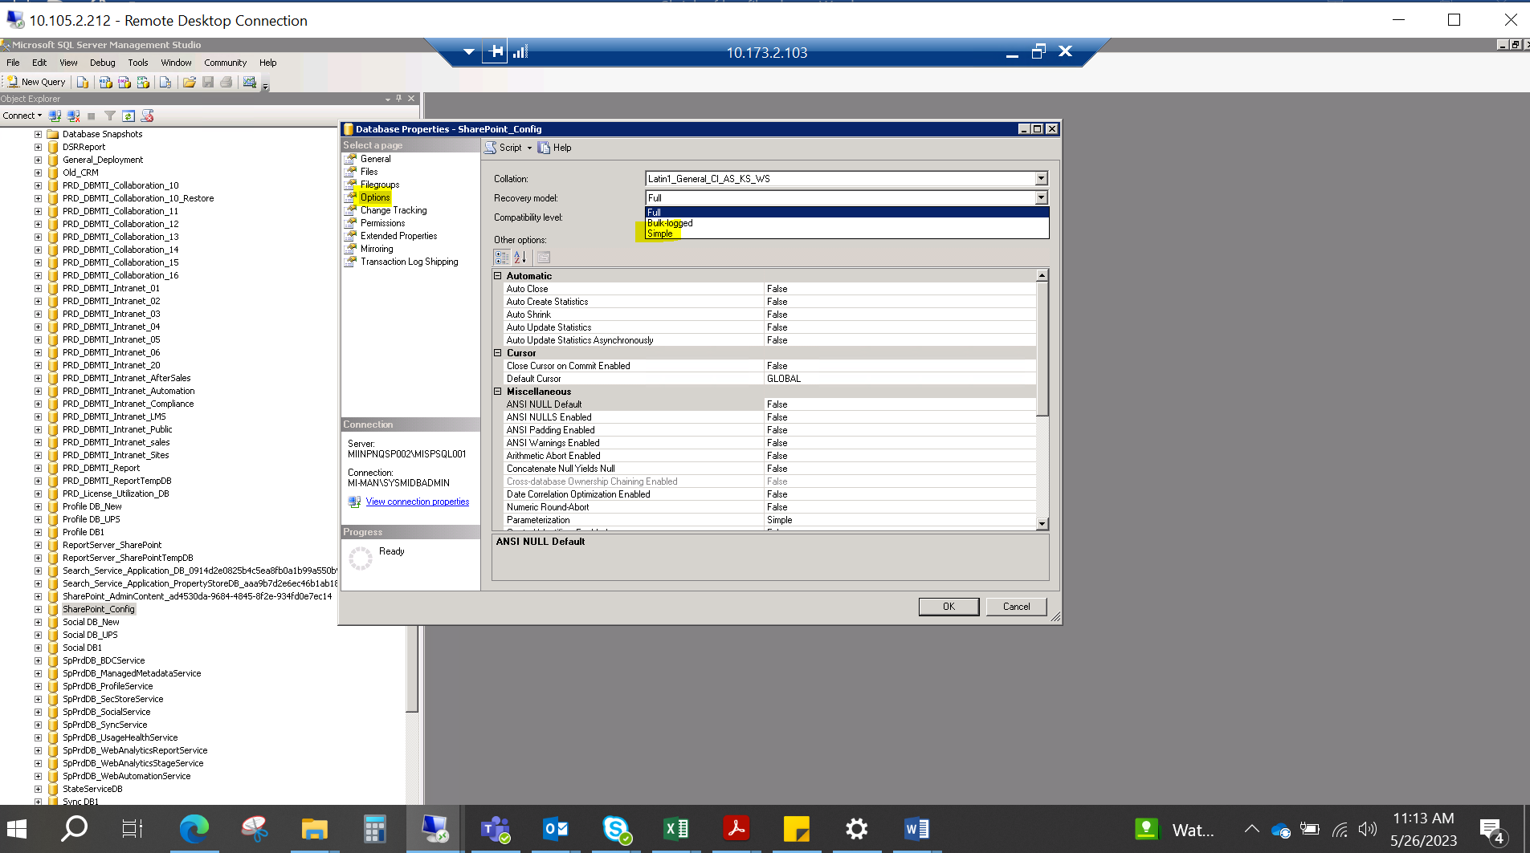

Step 2 :- Then we can shrink the database log files .

